Online Feature Selection and Its Applications

Abstract

Feature selection is an important technique for data mining. Despite its importance, most studies of feature selection are restricted to batch learning. Unlike traditional batch learning methods, online learning represents a promising family of efficient
and scalable machine learning algorithms for large-scale applications. Most existing studies of online learning require accessing all the attributes/features of training instances. Such a classical setting is not always appropriate for real-world applications when data instances are of high dimensionality or it is expensive to acquire the full set of attributes/features. To address this limitation, we investigate the problem of Online Feature Selection (OFS) in which an online learner is only allowed to maintain a classifier involved only a small and fixed number of features. The key challenge of Online Feature Selection is how to make accurate prediction for an instance using a small number of active features. This is in contrast to the classical setup of online learning where all the features can be used for prediction. We attempt to tackle this challenge by studying sparsity regularization and truncation techniques. Specifically, this article addresses two different tasks of online feature selection: (1) learning with full input where an learner is allowed to access all the features to decide the subset of active features, and (2) learning with partial input where only a limited number of features is allowed to be accessed for each instance by the learner. We present novel algorithms to solve each of the two problems and give their performance analysis. We evaluate the performance of the proposed algorithms for online feature selection on several public datasets, and demonstrate their applications to real-world problems including image classification in computer vision and microarray
gene expression analysis in bioinformatics. The encouraging results of our experiments validate the efficacy and efficiency of the proposed techniques.

Existing System:

The existing FS algorithms generally can be grouped into three categories: supervised, unsupervised, and semi-supervised FS. Supervised FS selects features according to labeled training data. Based on different selection criterions and methodologies, the existing supervised FS methods can be further divided into three groups: Filter methods, Wrapper methods, and embedded methods approaches. Filter methods choose important features by measuring the correlation between individual features and output class labels, without involving any learning algorithm; wrapper methods rely on a predetermined learning algorithm to decide a subset of important features. Although wrapper methods generally tend to outperform filter methods, they are usually more computationally expensive than the filter methods.
Proposed System

Online Feature Selection (OFS), which aims to select a small and fixed number of features for binary classification in an online learning fashion. In particular, we addressed two kinds of OFS tasks in two different settings: (i) OFS by learning with full inputs of all the dimensions/ attributes, and (ii) OFS by learning with partial inputs of the attributes. We presented a family of novel OFS algorithms to solve each of the OFS tasks, and offered theoretical analysis on the mistake bounds of the proposed OFS algorithms.

Process:

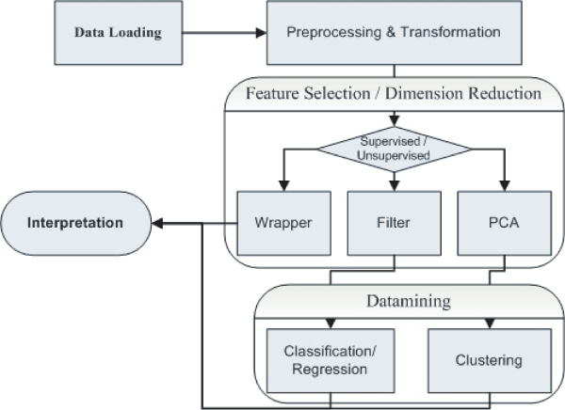

Modules

1. OFS: Learning with Partial Inputs

We note that this may be important for a number of applications when the attributes of objects are expensive to acquire. Evidently, we can not just acquire the B attributes that have non-zero values in the classifier wt. This is because in this way, the classifier will never be able to change the subset of attributes with non-zero elements, and it is easy to generate a sequence of training examples that lead to a poor classification performance for this approach. To address this challenge, we propose an ε-greedy online feature selection approach with partial input information by employing a classical technique for making tradeoff between exploration and exploitation. In this approach, we will spend ε of trials for exploration by randomly choosing B attributes from all d attributes, and the remaining 1−ε trials on exploitation by choosing the B attributes for which classifier wt has non-zero values. Algorithm 4 shows the detailed steps of the proposed OFSP algorithm. Finally, Theorem 2 gives the mistake bound of algorithm.
2. OFS with Full Input Information

Finally, Figure 2 further shows the details of the online performance of the compared online feature selection algorithms with varied fractions of selected features. The proposed OFS algorithms outperform the other two baselines for most cases. This encouraging result further verifies the efficiency of the proposed technique Application Modules

Guide Module:
In this module, guide view the participant registration, course enrolled status and participant doubts. The participant can clear the doubts by choosing the domain and entering the question. The guide view the participant doubt and sends reply according to the queries. The Questions will be hosted for the participant inorder to take exams. Guide will host question paper according to the domain and send to the participant.
Visualization
Visualization is any technique for creating images, diagrams, or animations to communicate a message. Visualization through visual imagery has been an effective way to communicate both abstract and concrete ideas since the dawn of man.

Web Television
Web television is original television content produced for broadcast via the World Wide Web. Web TV is a system through which television services are delivered using the Internet protocol suite over a packet-switched network such as the Internet, instead of being delivered through traditional terrestrial, satellite signal, and cable television formats

Security
Improve due to centralization of data, increased security-focused resources, etc., but concerns can persist about loss of control over certain sensitive data, and the lack of security for stored kernels. Security is often as good as or better than other traditional systems, in part because providers are able to devote resources to solving security issues that many customers cannot afford. However, the complexity of security is greatly increased when data is distributed over a wider area or greater number of devices and in multi-tenant systems that are being shared by unrelated users. In addition, user access to security audit logs may be difficult or impossible.

SOFTWARE REQUIREMENTS:

Operating System : Windows
Technology : Java and J2EE
Web Technologies : Html, JavaScript, CSS
IDE : My Eclipse
Web Server : Tomcat
Tool kit : Android Phone
Database : My SQL
Java Version : J2SDK1.5

HARDWARE REQUIREMENTS:

Hardware : Pentium
Speed : 1.1 GHz
RAM : 1GB
Hard Disk : 20 GB
Floppy Drive : 1.44 MB
Key Board : Standard Windows Keyboard
Mouse : Two or Three Button Mouse
Monitor : SVGA

